TryHackMe Writeup 03 — Basic Port Scans
Platform: TryHackMe | Room: Basic Port Scans (nmap02)
Internship topic: Network Traffic Analysis, Nmap and Windows Logging

1. Objective
Understand how TCP and UDP port scans work, how Nmap interprets port states, and what scan packets may look like in network traffic.

2. Key concepts

Open
A service responds on the target port.

Closed
The host responds but no service is listening on that port.

Filtered
A firewall or filtering device prevents Nmap from determining the port state.

TCP SYN scan (-sS)
Sends SYN probes. A SYN/ACK suggests an open port; an RST typically suggests a closed port.

TCP Connect scan (-sT)
Completes the TCP connection using the operating system connection mechanism.

UDP scan (-sU)
Sends UDP probes; ICMP unreachable responses or lack of responses can affect interpretation.

3. Commands and meaning
Command | Purpose
nmap -sS <target> | TCP SYN scan
nmap -sT <target> | TCP connect scan
nmap -sU <target> | UDP scan
nmap -p 22,80,443 <target> | Scan selected ports
nmap -p- <target> | Scan all TCP ports
nmap -sV <target> | Identify service versions

4. Week 2 lab connection
In my separate internship Nmap practical, I scanned my own Ubuntu and Windows virtual machines, saved outputs in normal TXT and XML formats, and captured SYN-scan traffic in Wireshark. This practical evidence is stored in the Nmap Findings and Captures folders. These observations are from the internship lab, not claimed as commands executed inside the TryHackMe room.

5. SOC analyst perspective
A rapid sequence of SYN probes to different destination ports can be a sign of network reconnaissance. Analysts should compare source, destination, timing, TCP flags, and the normal baseline before deciding whether activity is suspicious.

6. Evidence
TryHackMe completion evidence: Basic_Port_Scans.png (provided in the original Week 2 archive).
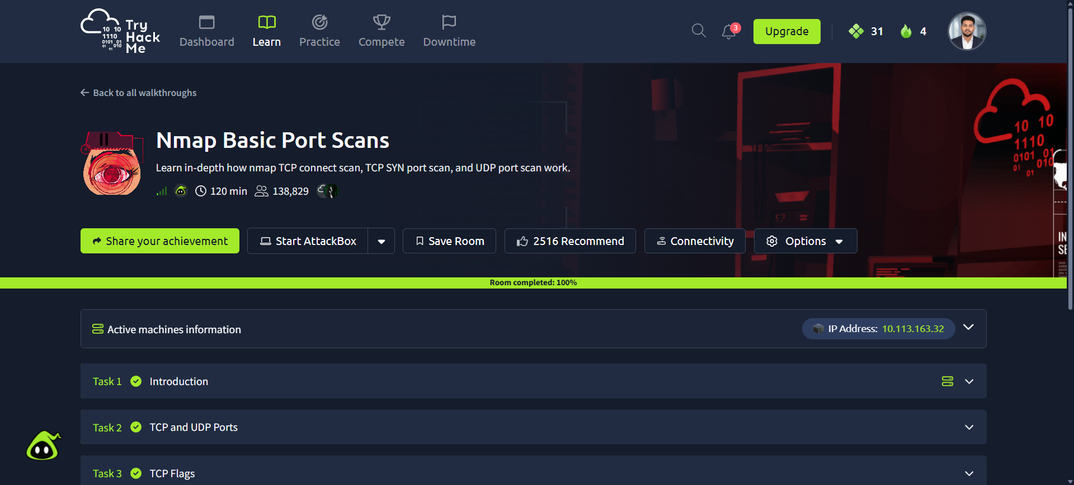

7. Conclusion
This room reinforced how port scanning works and why scan traffic matters in security monitoring. My Week 2 lab provided a separate opportunity to observe SYN-scan packets and record Nmap results.

